Log Volunteer Hours

 | Click the ‘LOG HOURS’ link on the top navigation row.
 | Use the search fields to find the organization name.  Note: If you cannot locate your organization follow the next set of instructions (on page. 3) to ‘Nominate an Organization’ to be included in the search results of the databse. | 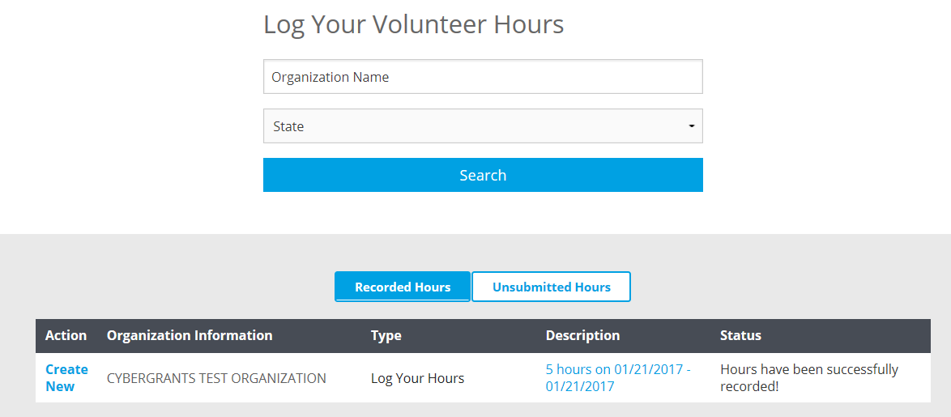
3. | Enter the details related to your volunteer service as well as total hours for any friend/family volunteers and select the ‘Save and Proceed’ button at the bottom of the page. | 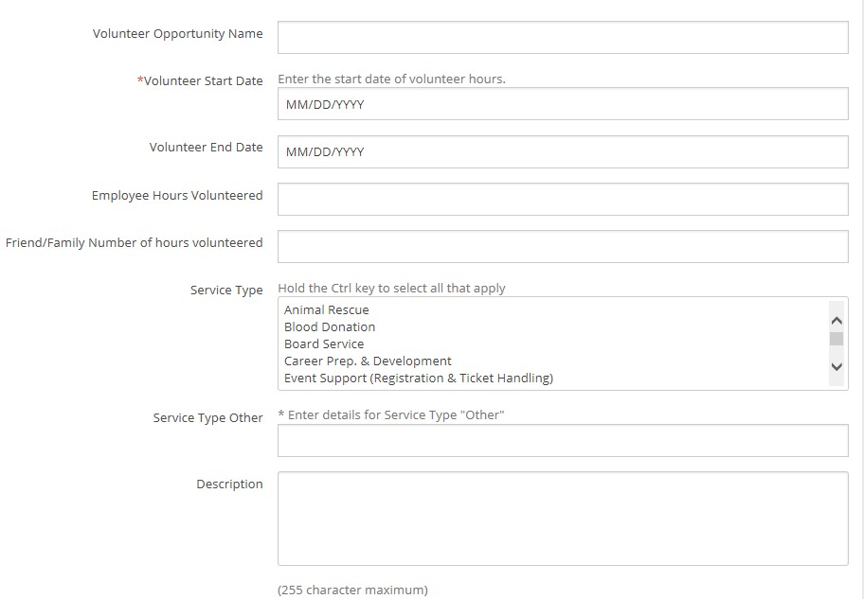
4. | Review your information.  Submit  Click the ‘Submit’ button to immediately send the logged hours to Community Relations and you will then be unable to perform further editing.  Save Only  If you are not ready to submit your hours at this time, click the ‘Save Only’ button. The request will then be available to edit from the Welcome page. | 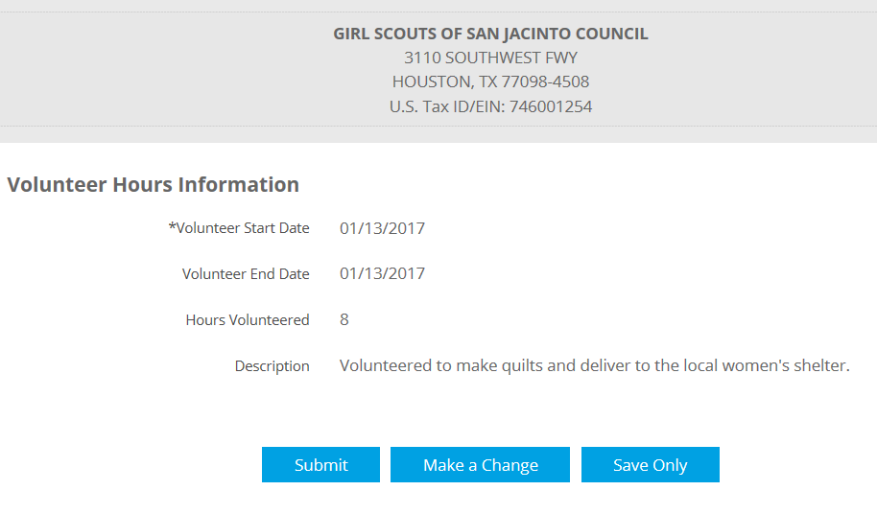
5. | You will receive see a confirmation message that you have successfully submitted volunteer hours.
 | END

Nominate an Organization
If you would like to nominate an organization that is not currently listed in the search result; you may nominate the organization by following the instructions below.

 | Select the ‘Nominate your organization’ link towards the bottom of the page. | 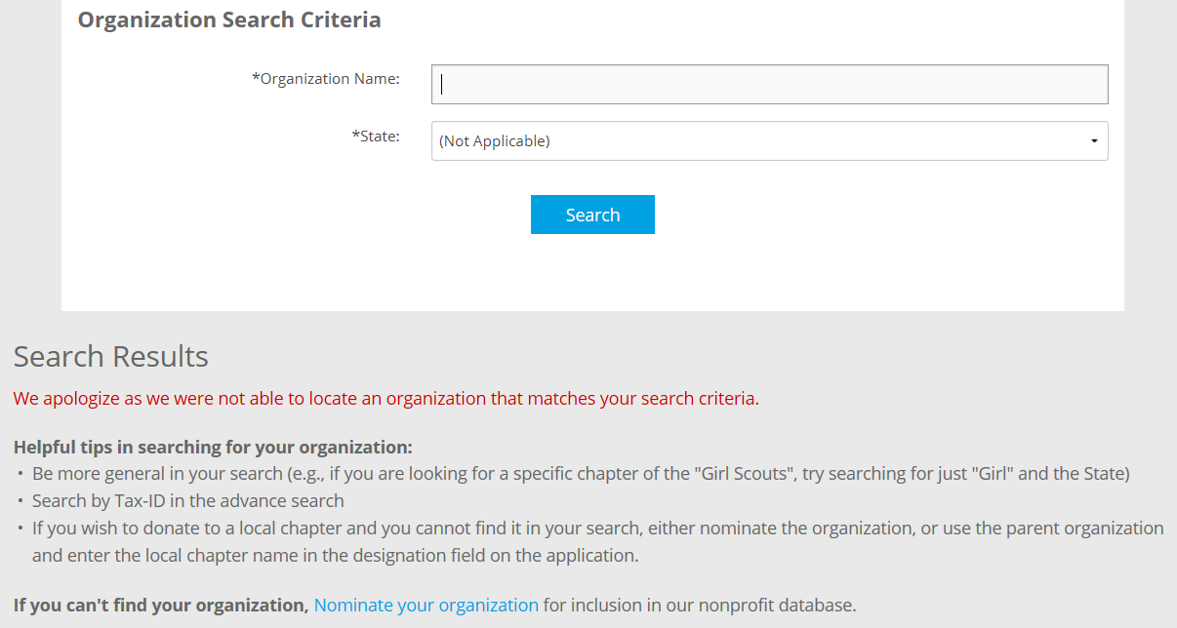
2. | Complete the organization nomination information and select the ‘Review’ button near the bottom of the screen when complete. | 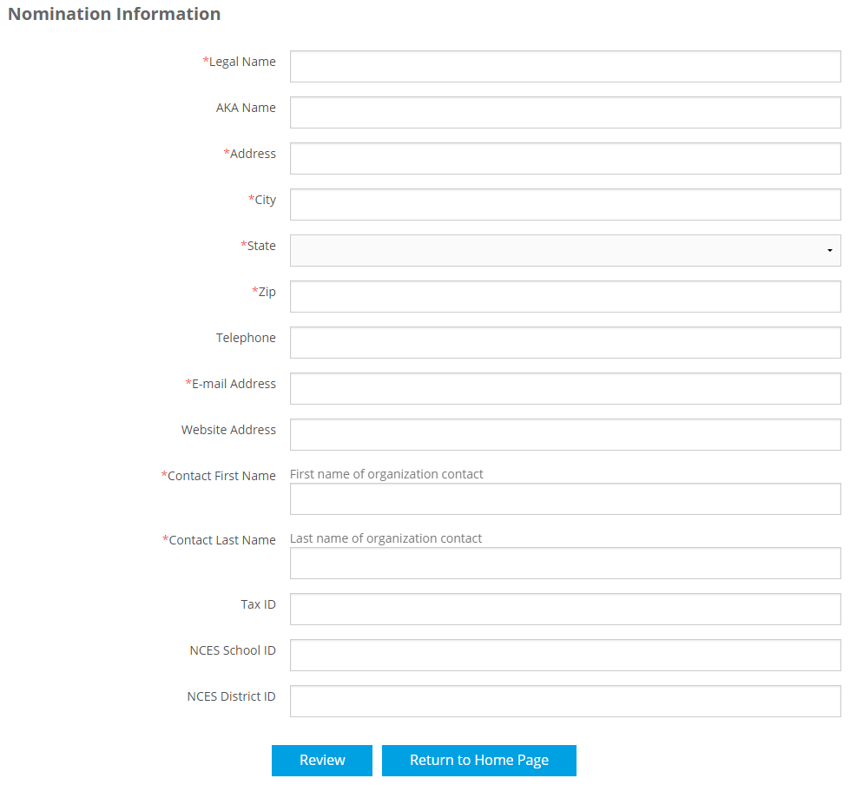
3. | Review the nomination information on the next screen for accuracy and completeness and click ‘Submit’ at the bottom of the screen.
4. | You will receive a confirmation message stating your nomination was successful.  Try the search once more and verify that your organization is listed in the search results. | 